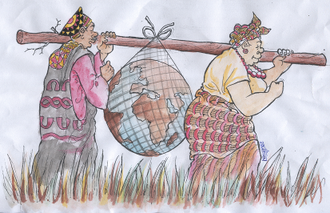
CAMEROON GENDER AND ENVIRONMENT WATCH
(CAMGEW)
Authorisation Nº.000998/RDA/J06/BAPP
Tel: (237) 675184310/697037417
www.camgew.com
Email: camgew@yahoo.com; camgew@gmail.com; P.O. Box 17 Oku, North West Region, Cameroon

Donation form
Personal Information
- Your name.................................................................................................................................................................
- Project/Activity supported...............................................................................................................................
- Amount donated....................................................................................................................................................
- Nationality................................................................................................................................................................
- Country of residence............................................................................................................................................
- Contact information.............................................................................................................................................

Our bank information
Account Holder
Name | Cameroon Gender and Environment Watch (CAMGEW)
Bank
Bank Name | Banque Atlantique, Cameroon
Country | Cameroon
Account number | 10034000503715053410106
IBAN | IBAN : CM21 10034 00050 3715053410106
BIC/SWIFT code | ATCRCMCM

Thank you for helping us to help our community

Should you feel as visiting us we assure you of your security with us.
Our community is rural, receptive, quiet, touristic with many local carvers, mountainous forest, various types of honey producers, many traditional dances, cultural displays, museums, lake, bird diversity, local paper industry, animal and plant diversity, etc

